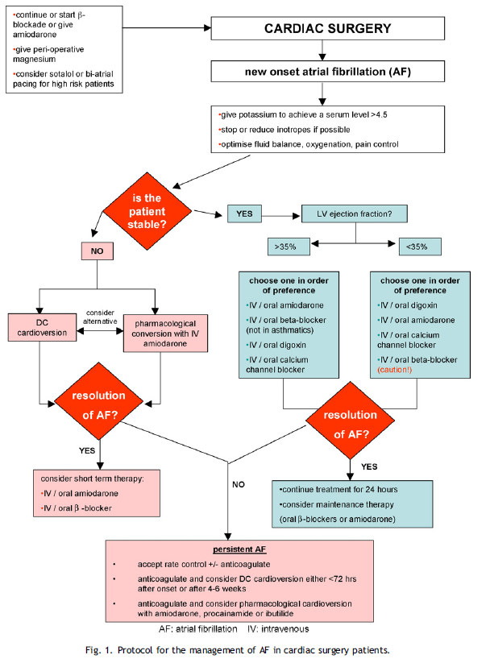
In addition to the searches mentioned above, several guidelines and reviews were also considered prior to deriving a protocol for the management of patients going into AF after cardiac surgery [7,16,105—117] including this year’s guideline from the National Institute for Health and Clinical excellence (www.nice.org.uk). A protocol is presented, based on the evidence in this guideline and on the protocol derived by Thompson et al. [105] in Fig. 1. (Reproduced with modifications with kind permission from the authors.)

